Lab 1 Assignment: Control Volume Analysis

Prepared by: Team 4
Lucas Rodrigues (rodr1053@purdue.edu)
Arnav Basu (basu41@purdue.edu)
Arnav Shah (shah965@purdue.edu)
Matthew Ginart (mginart@purdue.edu)

School of Mechanical Engineering,
Purdue University
585 Purdue Mall
West Lafayette, IN 47907

Date: 2026.09.18

Submitted to: Dr. Weixiao Shang

Objective:
- Design and carry out a test plan to measure velocity and pressure fields around a circular cylinder at various Reynolds numbers.
- Process the collected data to compute the drag force and drag coefficient.

Schematic:
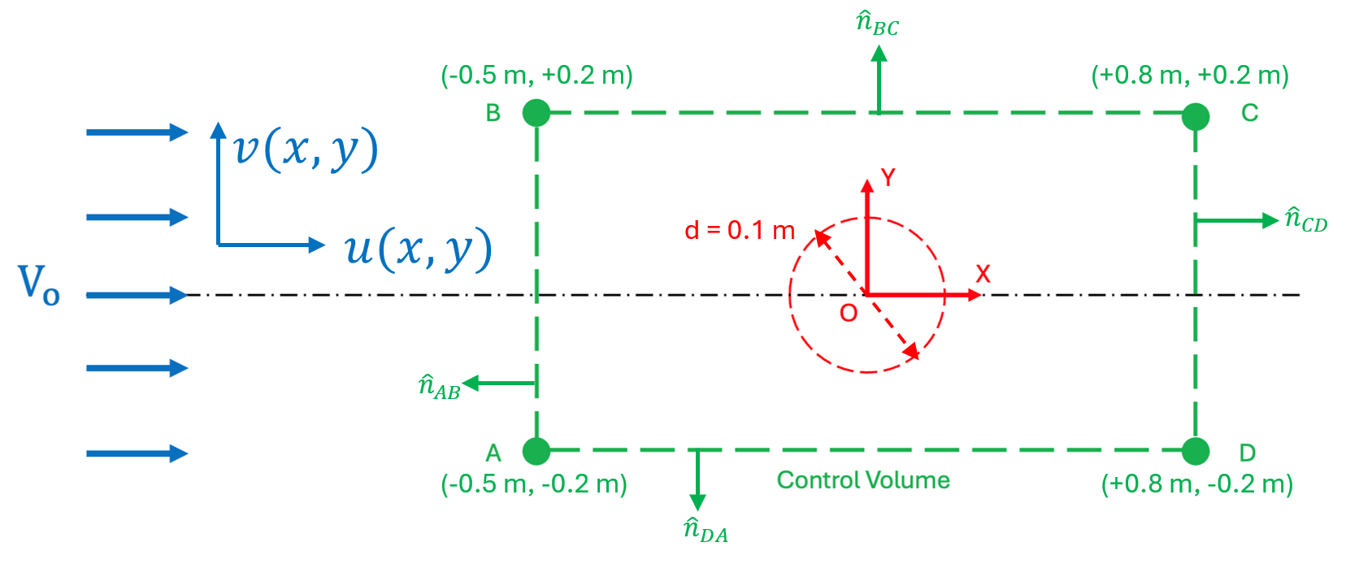
Figure 1: Control Volume used for Momentum Analysis

Assumptions:
- Steady State
- Long cylinder (2D flow)
- Air properties at standard atmospheric conditions
- No body forces in x-direction
- Incompressible Fluid

Basic Equations:
$\frac{∂}{∂t}\int_{\text{CV}}{ρdV}+\int_{\text{CS}}{ρ\vec{V}}d\vec{A}=0$ (1)
$\frac{∂}{∂t}\int_{\text{CV}}{uρdV}+\int_{\text{CS}}{uρ\vec{V}}d\vec{A}=F_{s,x}+F_{B,x}$ (2)
$F_{D}= C_{D}\frac{1}{2}ρV^{2}A$ (3)

Simplify Eq (2):
$\frac{∂}{∂t}\int_{\text{CV}}{uρdV}+\int_{\text{CS}}{uρ\vec{V}}d\vec{A}=F_{s,x}+F_{B,x}$ (2)
Starting from Eq (2), we apply our steady state assumption, and the unsteady term is eliminated. We also apply our “no body forces in x-direction” assumption and eliminate $F_{B,x}$. This gives us the following: $\int_{\text{CS}}{uρ\vec{V}}d\vec{A}=F_{s,x}.$ Since we are assuming that the fluid is incompressible, we can say that density is constant, factoring it out. We are left with the following equation:
$$ρ\int_{\text{CS}}{u\vec{V}}d\vec{A}=F_{s,x} (4)$$

Expand the CS term and apply it on each side. Make sure to use the correct velocity vector component on each side of the CV.
$$\int_{\text{CS}}{uρ\vec{V}}d\vec{A}=\int_{A}^{B}{uρ\vec{V}}d\vec{A}+\int_{B}^{C}{uρ\vec{V}}d\vec{A}+\int_{C}^{D}{uρ\vec{V}}d\vec{A}+\int_{D}^{A}{uρ\vec{V}}d\vec{A}$$
To assist with this expansion, note that $d\vec{A}= \hat{n}dA$. Additionally, flow is assumed to be incompressible (constant $ρ$) and each face is going to be contributing along its normal axis. For the AB (left) face that is along $-\hat{i}$, BC (top) face $+\hat{j}$, CD (right) face $+\hat{i}$, and DA (bottom) face $-\hat{j}$. For the vertical faces $dA$ will become $dy$ and for the horizontal faces it will become$dx$. Applying these simplifications, we get the following:
$$\int_{A}^{B}{uρ\vec{V}}d\vec{A}=ρ\int_{A}^{B}{u(\vec{V}∙}\hat{n})dA=-ρ\int_{-0.2}^{0.2}{u^{2}dy},$$
$$\int_{B}^{C}{uρ\vec{V}}d\vec{A}=ρ\int_{B}^{C}{u(\vec{V}∙}\hat{n})dA=+ρ\int_{-0.5}^{0.8}{uvdx},$$
$$\int_{C}^{D}{uρ\vec{V}}d\vec{A}=ρ\int_{C}^{D}{u(\vec{V}∙}\hat{n})dA=+ρ\int_{-0.2}^{0.2}{u^{2}dy},$$
$$\int_{D}^{A}{uρ\vec{V}}d\vec{A}=ρ\int_{D}^{A}{u(\vec{V}∙}\hat{n})dA=-ρ\int_{-0.5}^{0.8}{uvdx}$$
All together and using Eq (4) from the previous part we can see that:
$$\int_{\text{CS}}{uρ\vec{V}}d\vec{A}=F_{s,x}= ρ\left(\underset{AB}{\underbrace{-\int_{-0.2}^{0.2}{u^{2}dy}}}+\underset{BC}{\underbrace{\int_{-0.5}^{0.8}{uvdx}}}+\underset{CD}{\underbrace{\int_{-0.2}^{0.2}{u^{2}dy}}}\underset{DA}{\underbrace{-\int_{-0.5}^{0.8}{uvdx}}}\right) (5)$$
It is very important to note that, for example, the $u$ acting on face AB is not the same as the one on CD despite how the equation makes it appear. The integrals do not cancel each other out to make $F_{s,x}=0$.
What are the surface forces that can be applied on the CV?
The surface forces acting on our control volume in the x-direction come from both pressure acting on the four surfaces of the CV and the reaction (drag) force from the inner control surface around the cylinder. We will let $F_{D}$ be the drag force exerted by the fluid on the cylinder, which is positive in the x-direction. This means that the cylinder exerts $-F_{D}$ onto the fluid within our control volume. Since pressure always acts opposite our outward normal vectors, we will start by simplifying $d\vec{F}$ from $-p\vec{dA}$to $-p\hat{n}dA$. Additionally, the top and bottom faces of our CV will not have contributing surface forces in the x-direction since their normal vectors are aligned with the established y-axis. This allows us to find our surface force as follows:
$F_{s,x}=\underset{All Faces}{\underbrace{\int{-pn_{x}dA}}}-F_{D}=\underset{AB}{\underbrace{\int{-pn_{x}dA}}}+\underset{CD}{\underbrace{\int{-pn_{x}dA}}}-F_{D}$ =$\underset{AB}{\underbrace{\int{pdy}}}-\underset{CD}{\underbrace{\int{pdy}}}-F_{D} (6)$

Solve for $F_{D}:$
The final expression for $F_{D}$ can be found as follows using Eq (5) and Eq (6):
$$F_{s,x}=\underset{AB}{\underbrace{\int{pdy}}}-\underset{CD}{\underbrace{\int{pdy}}}-F_{D}→F_{D}=\underset{AB}{\underbrace{\int{pdy}}}-\underset{CD}{\underbrace{\int{pdy}}}-F_{S,x}→$$
$$F_{D}=\underset{AB}{\underbrace{\int{pdy}}}-\underset{CD}{\underbrace{\int{pdy}}}+ ρ\left(\underset{AB}{\underbrace{\int_{-0.2}^{0.2}{u^{2}dy}}}-\underset{BC}{\underbrace{\int_{-0.5}^{0.8}{uvdx}}}-\underset{CD}{\underbrace{\int_{-0.2}^{0.2}{u^{2}dy}}}\underset{DA}{\underbrace{+\int_{-0.5}^{0.8}{uvdx}}}\right) (7)$$

Solve for $C_{D}:$
$F_{D}= C_{D}\frac{1}{2}ρV^{2}A$ (3)

Using the expression for $F_{D}$ from Eq (7), we can rearrange Eq (3) and come to a final expression for $C_{D}$. Because flow is assumed to be 2D, we can evaluate $F_{D}$ and $A$per unit depth into the page. This allows us to set $A=d$ (the cylinder’s diameter) in this expression. The work is as follows:
$$F_{D}= C_{D}\frac{1}{2}ρV^{2}A→C_{D}=\frac{F_{D}}{\frac{1}{2}ρV^{2}A}→$$
$$C_{D}=\frac{F_{D}}{\frac{1}{2}ρV^{2}d}$$
$$\left(short form\right)$$

$$C_{D}=\frac{\left(\underset{AB}{\underbrace{\int{pdy}}}-\underset{CD}{\underbrace{\int{pdy}}}+ ρ\left(\underset{AB}{\underbrace{\int_{-0.2}^{0.2}{u^{2}dy}}}-\underset{BC}{\underbrace{\int_{-0.5}^{0.8}{uvdx}}}-\underset{CD}{\underbrace{\int_{-0.2}^{0.2}{u^{2}dy}}}\underset{DA}{\underbrace{+\int_{-0.5}^{0.8}{uvdx}}}\right) \right)}{\frac{1}{2}ρV^{2}d} (8)$$
$$(full form)$$
Note post-processing:
The drag coefficients computed with our gathered data do not follow the expected monotonic trend for a circular cylinder. This is likely due to using too few probes on our BC and DA faces along with a control volume whose height ($±2d)$ is too short to fully contain the wake. This allows for some momentum flux to be unaccounted for as it crosses the top and bottom faces. The measured inlet velocity at $Re=5$also differs from the expected value by $\sim 10×$, suggesting that there is an error in that testing condition.

